**PRACTICAL 1**

**AIM: Introduction Virtualization Environment configuration and Cyber Lab setup (Kali, VM ware and Oracle VirtulBox).**

1. Download And Install VirtualBox

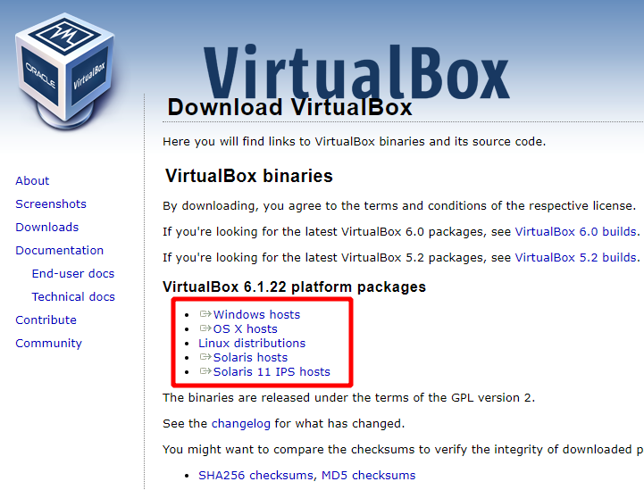

Once the download is completed, double-click on the installation file to launch the VirtualBox installer.

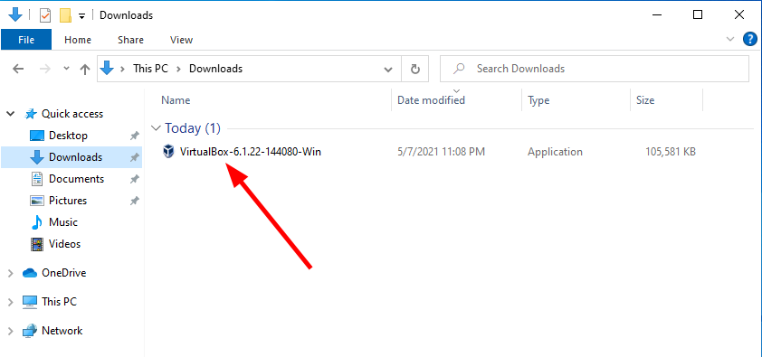

On the VirtualBox Welcome window, click the Next button

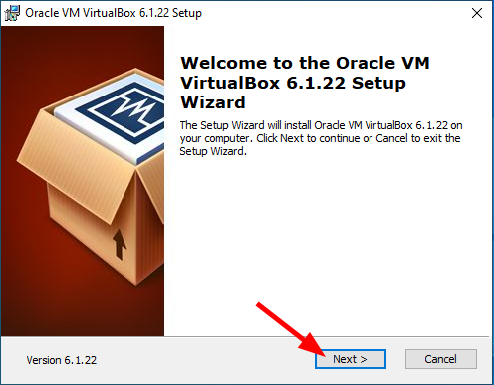

On the VirtualBox Customer Setup window, click the Next button

Alternatively, you can browse for a new location on your machine to install the VirtualBox or customize your installation further

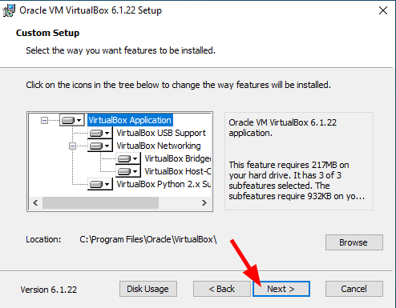

Check/uncheck the shortcut options or leave the default selection then click the Next button

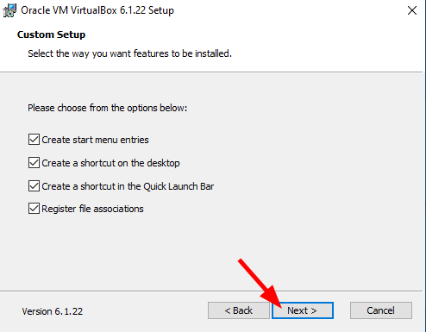

The VirtualBox installer will proceed to configure the virtual network interface on your VM therefore the network connection will reset shortly. Click Yes to continue the installation.

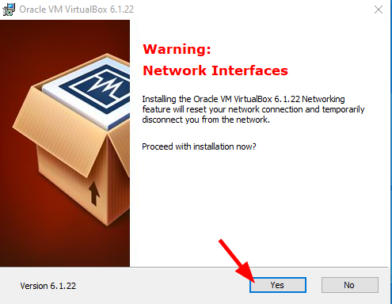

On the Ready to Install window click Install to start the VirtualBox installation.

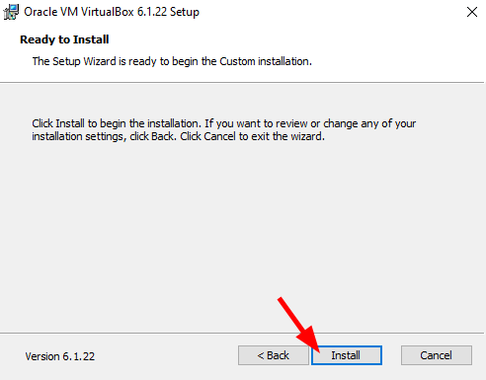

On the User Account Control window, click Yes [Figure 1.8].

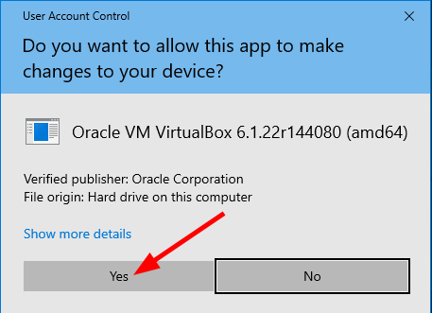

 VirtualBox installation – User Account Control.

When prompted to allow the Oracle Corporation Universal Serial Bus controller, click the Install button

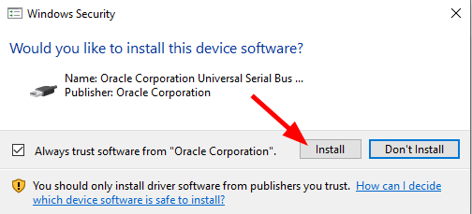

VirtualBox installation – Oracle virtual USB controller.

The VirtualBox installation is now completed. Click the Finish button to exit the installer

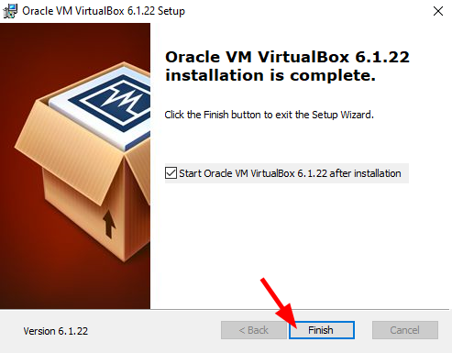

 VirtualBox installation – Finish.

VirtualBox is now installed on your computer. You should see a window similar to the one in below.

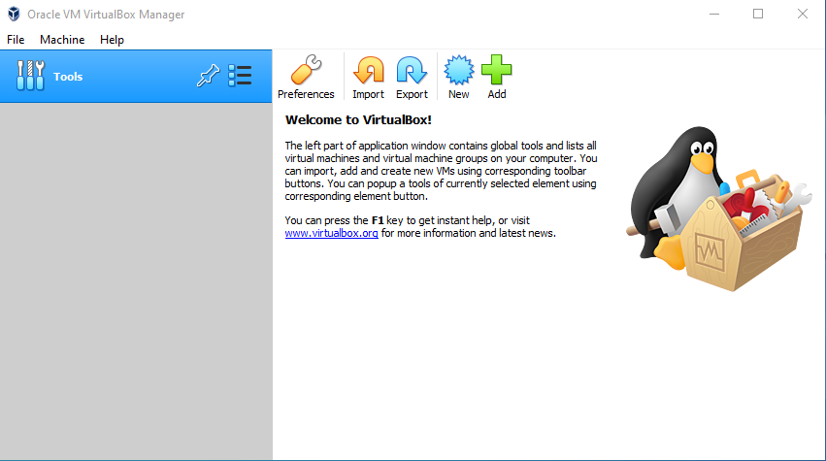

## 2. Install Kali Linux in VirtualBox

### **Step 1: Download Windows 10 VirtualBox** VM

### **Step 2: Import Windows 10 VM in VirtualBox**

### **Step 3: Boot into Windows 10 VM**

### Virtual Hacking Lab - Windows 10 VM. Source: nudesystems.com

**PRACTICAL 2**

**AIM: Information Gathering using NMAP framework and study about port scanning.**

1. TCP Connect Scan (-sT): TCP Connect scan uses the concept of a full three-way handshake to discover whether a given port is open, filtered, or closed according to the response it receives. Nmap sends a TCP request packet to each and every port specified and determines the status of the port by the response it receives.

What it essentially means is that if Nmap sends a TCP request to a closed port with its SYN flag set, then it receives a TCP packet with its RESET FLAG set from the target server. This tells Nmap that the specified port is “closed”.

Otherwise, if the port is actually “open”, then Nmap receives a response with SYN/ACK flags set responding to the packet sent by Nmap with its SYN flag set.

The third possibility is that if a port is filtered, most of the server’s firewalls are configured to just drop incoming packets. Nmap doesn’t receive any response back. This essentially means that the given port is running behind a firewall (i.e “filtered”).

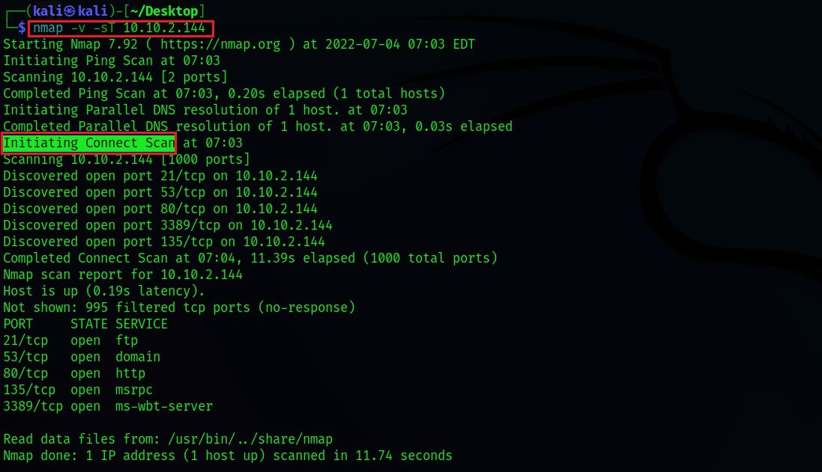

2. TCP SYN Scan (-sS): SYN scans are often called “Half-open” or “Stealth” scans. SYN scan works the same way as TCP Connect scan with closed and filtered ports i.e receives a RST packet for closed port and no response for filtered ports. The only difference is in the way they handle the open ports. SYN scan sends a response packet to the server with its RESET FLAG set(but not ACK which is usually the default in the actual three-way handshake) after receiving SYN/ACK from the target server. This is to avoid the server from continuously making requests to establish a connection and thereby reduce the scan time.

This scan type is referred to as a stealth scan due to the following advantages:

Faster because it doesn’t have to complete the full three-way handshake.

Some applications often log only those connections that are fully established. So applications listening on open ports do not log these connections which makes SYN scan “stealthy”.

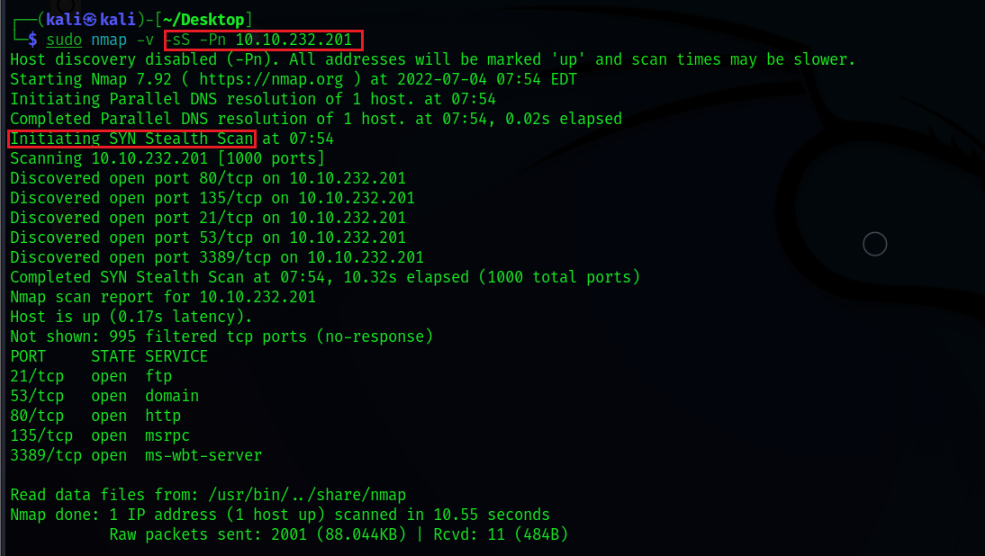

3. UDP Scan (-sU): UDP unlike TCP, doesn’t perform a handshake to establish a connection before sending data packets to the target port but rather sends the packets hoping that the packets would be received by the target port. That is why UDP connections are often called “stateless”. This type of connection is more efficient when speed dwarfs quality, like in video sharing. As there will be no acknowledgment from the target port whether it has received the packet, UDP scans become more difficult and very much slower.

When there’s no response from the target port after sending a UDP packet, it often times means that the port is either “open” or is running behind a firewall i.e “filtered” in which case the server would just drop the packet with no response.

UDP scan can effectively identify closed ports as the target UDP port responds with an ICMP packet with a message that the port is unreachable.

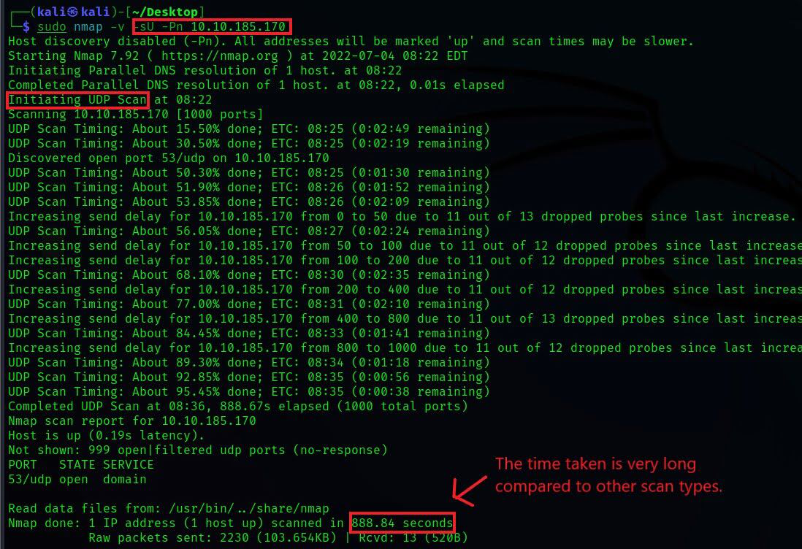

The below scan techniques are very less likely to be used in real-time but it’s worth learning the principle behind them. They are said to be even stealthier than the “SYN stealth” scan.

For the below scan types, when a packet is sent to an “open” port, there won’t be any response from the target port which is very similar to the UDP scan. When the below scan types don’t get a response, they would mark the port as being open/filtered. As per RFC 793, for malformed packets, the closed ports on the server are mandated to respond with an RST TCP packet and no response at all for open ports.

TCP NULL Scan (-sN): NULL scan, as the name implies, sends a TCP packet with no flags set. If the port is closed, the host responds with an RST.

TCP FIN Scan (-sF): FIN scan, rather than sending completely empty packets, it sends a packet with its FIN flag set. If the port is closed, the host responds with an RST.

TCP XMAS Scan (-sX): XMAS scan, sends a packet with URG,PSH,FIN flags set. This scan got its name from the appearance it gives of a Christmas tree when viewed as a packet capture in Wireshark. If the port is closed, the host responds with an RST.

**PRACTICAL 3**

**AIM: Understand packet capturing tool wireshark or Ethercap and analysis of those packets.**

Wireshark captures the data coming or going through the NICs on its device by using an underlying packet capture library. By default, Wireshark captures on-device data only, but it can capture almost all the data on its LAN if run in promiscuous mode. Currently, Wireshark uses NMAP’s Packet Capture library(called npcap).

Getting Up and Running: After installation launch Wireshark, approve the administrator or superuser privileges and you will be presented with a window that looks like this:

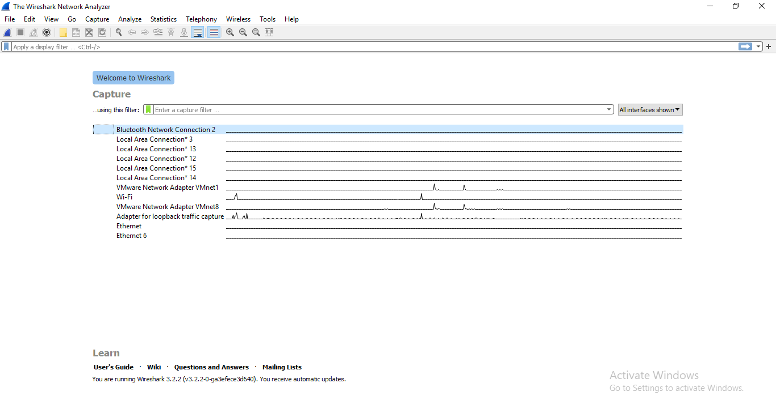

This window shows the interfaces on your device. To start sniffing select one interface and click on the bluefin icon on the top left. The data capture screen has three panes. The top pane shows real-time traffic, the middle one shows information about the chosen packet and the bottom pane shows the raw packet data. The top pane shows source address(IPv4 or IPv6) destination address, source and destination ports, protocol to which the packet belongs to and additional information about the packet.

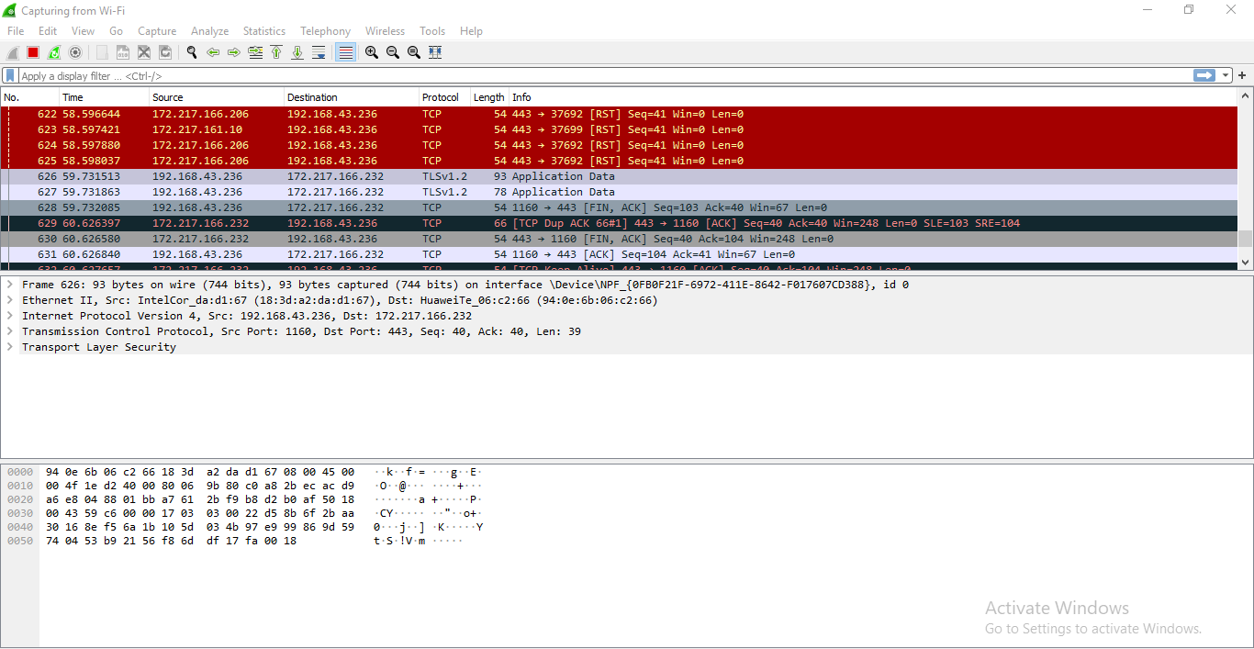

Since there are a lot of packets going in and out every second, looking at all of them or searching for one type of packets will be tedious. This is why packet filters are provided. Packets can be filtered based on many parameters like IP address, port number or protocol at capture level or at display level. As obvious a display level filter will not affect the packets being captured.

Some of the general capture filters are:

host (capture the traffic through a single target)

net( capture the traffic through a network or sub-network). “net” can be prefixed with “src” or “dst” to indicate whether the data coming from or going to the target host(s).)

port (capture the traffic through or from a port). “port” can be prefixed with “src” or “dst” to indicate whether the data coming from or going to the target port.

“and”, “not” and “or” logical connectives.(Used to combine multiple filters together).

There are some more basic filters and they can be combined very creatively. Another range of filters, display filters are used to create abstraction on captured data. These basic examples should provide a basic idea of their syntax:

tcp.port==80/udp.port==X shows the tcp/udp traffic at port X.

http.request.uri matches “parameter=value$” shows packets that are HTTP requests at the application layer level and their URI ends with a parameter with some value.

The logical connective and or and not work here too.

ip.src==192.168.0.0/16 and ip.dst==192.168.0.0/16 will show traffic to and from workstations and servers.

There is also a concept of coloring rules. Each protocol/port/other element is provided a unique color to make it easily visible for quick analysis. More details on coloring rules is here

Plugins are extra pieces of codes that can be embedded into the native Wireshark. Plugins help in analysis by:

Showing parameter specific statistics and insights.

Handling capture files and issues related to their formats.

Collaborating with other tools and frameworks to set up an all-in-one network monitoring solution.

With just the basic capability to see all the traffic going through your device or in your LAN and the tools and plugins to help you in analysis, you can do a great deal of things with your device. Like:

Troubleshooting Internet connectivity problems with your device or WiFi.

Monitoring your device for unwanted traffic that may be an indication of a malware infection.

Testing the working of your application that involve networking.

Using it to just understand how computer networks work.

**PRACTICAL 4**

**AIM: Using open port information perform MITM(Man In The Middle) attack using arpspoof, urlsnarf, dsniff, dnsspoof.**

**1. Interruption**

**2. Interception**

A **man-in-the-middle (MITM) attack** is a type of cyber attack where a third-party intercepts the communication between two parties and secretly alters or eavesdrops on the messages. The attacker can use various techniques, such as phishing or session hijacking, to gain access to the communication channel. Once the attacker gains control of the communication, they can intercept and modify messages, steal sensitive information, or even impersonate one of the parties involved. This type of attack is particularly dangerous because it can be difficult to detect and can compromise the security of confidential data.

ARP spoofing is a **Man In The Middle (MITM)** attack in which the attacker (hacker) sends forged ARP Messages. This allows the attacker to pretend as a legitimate user as it links the attacker machine’s MAC Address to the legitimate IP Address. Once the MAC Address has been linked the attacker will now receive the messages intended for the legitimate IP Address. Furthermore, ARP Spoofing allows the attacker can intercept, modify, and drop the incoming messages. ARP Spoofing is only possible on 32-bit IP Addresses (IPv4) and not on IPv6.However, it is widely used because most of the internet still works on IPv4.

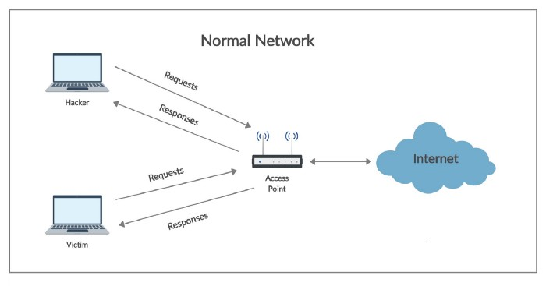

demonstrates the working of a normal network (no malicious activity) and how a device (hacker or victim) access the Internet with the help of an access point. All the messages pass through the access point. For instance, a device (hacker or victim) sends requests to access the resources on the Internet and in turn, receives responses. These **requests**and **responses**always pass through the access point and therefore the access point is called the **Gateway** to the Internet.

Hope all that makes sense! Let's get started with our MitM attack by opening up [BackTrack](https://null-byte.wonderhowto.com/how-to/hack-like-pro-getting-started-with-backtrack-your-new-hacking-system-0146889/)!

## Step 1 Open Three Terminals

To conduct this MitM attack, we're going to need three (3) terminals, so go ahead and open those now. Our goal here is to get a client on our network to believe we are the server and the server to believe we are the client.

[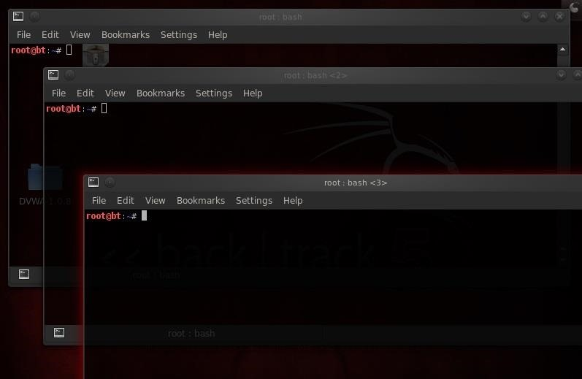](https://img.wonderhowto.com/img/original/81/64/63516748577782/0/635167485777828164.jpg)

**arpspoof** can do this for us by replacing the MAC address of the client and the server with our MAC address in the ARP table.

## Step 2 Arpspoof Client to Server

Let's start with the client. We want to replace the MAC address of the server with our MAC address.

* **arpspoof 192.168.1.101 192.168.1.105**

Where:

* **192.168.1.101** is the IP of the client
* **192.168.1.105** is the IP of the server

In this step, we're telling the client that we are the server.

## Step 3 Arpspoof Server to Client

Now we want to replace the MAC address of the client with our address, so we simply reverse the order of the IP addresses in the previous command.

* **arpspoof 192.168.1.105 192.168.1.101**

[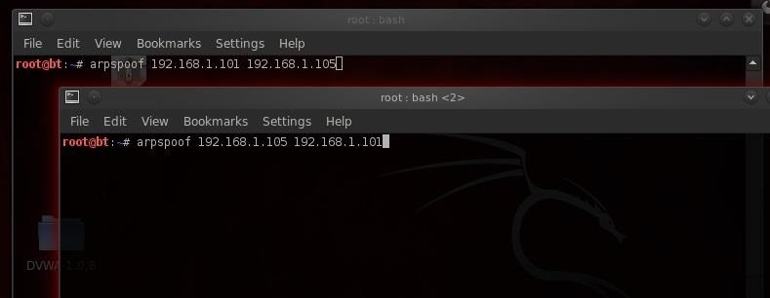](https://img.wonderhowto.com/img/original/08/67/63516749073302/0/635167490733020867.jpg)

Here, we are telling the server that we are the client.

Now execute both of these commands. When we do this, the client will think we are the server and the server will think we are the client!

[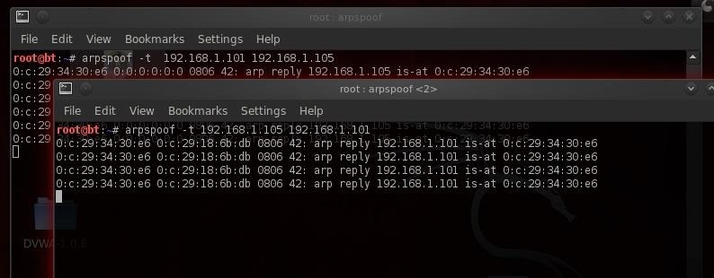](https://img.wonderhowto.com/img/original/66/81/63516749176558/0/635167491765586681.jpg)

## Step 4 Pass Packets with Ipforward

Now that we are impersonating both the client and server, we need to be able to pass or forward the packets to the other machine. In other words, we want the packets coming from the server to be forwarded to the client and those coming from the client forwarded to the server.

We do this in Linux by using the **ip_forward**. Linux has a built-in functionality to forward packets it receives. By default, it's turned off, but we can turn it on by changing its value to 1(ON).

We simply echo a 1 and direct (>) it to /proc/sys/net/ipv4/ip_forward, thereby turning on ipforwarding.

* **echo 1 > /proc/sys/net/ipv4/ip_forward**

[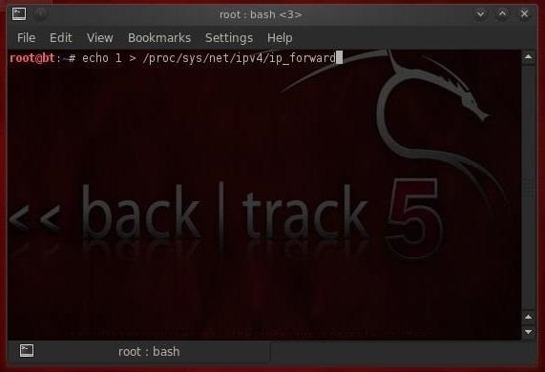](https://img.wonderhowto.com/img/original/26/60/63516767269564/0/635167672695642660.jpg)

Image via [wonderhowto.com](https://www.wonderhowto.com/)

Now our system, in the middle, is forwarding the traffic it receives to both ends of this connection, client and server.

## Step 5 Sniff the Traffic with Dsniff

Now that we have all the traffic coming from the client to the server and the server to the client going through our computer, we can sniff and see all the traffic!

To do this, we could use a number of different sniffing tools, including Wireshark or tcpdump, but in this case we'll use Dug Song's **dsniff**. Song designed dsniff to sniff out authentication information that appears on the wire in clear text (non-encrypted). So, protocols such as ftp, telnet, HTTP, SNMP, POP, LDAP, etc. can be sniffed off the wire.

To activate dsniff, we simply type:

* **dsniff**

[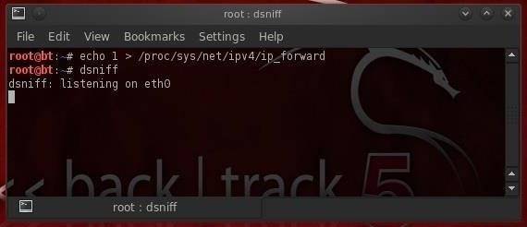](https://img.wonderhowto.com/img/original/93/87/63516767310997/0/635167673109979387.jpg)

Image via [wonderhowto.com](https://www.wonderhowto.com/)

As we can see, dsniff responds that it is listening on eth0.

## Step 6 Grab the FTP Credentials

Now, let's wait until the client logs into the ftp server. When he does so, dsniff will grab his credentials and display them to us.

[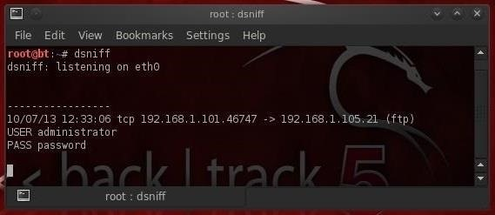](https://img.wonderhowto.com/img/original/38/37/63516767336566/0/635167673365663837.jpg)

Image via [wonderhowto.com](https://www.wonderhowto.com/)

As you see in the screenshot above, dsniff has grabbed the ftp credentials of the administrator with the password of "password"! How easy was that!

It's important to note that users and administrators often use that same username and password on all services and systems. Now that we have the admin's ftp password, the next step is to try to log in with it.

### **Interception**

An interception is where an unauthorized individual gains access to confidential or private information. **Interception attacks** are attacks against network the **confidentiality**objective of the CIA Triad.

Figure 11: Interception Attacks. (["Security Attacks: Interception"](https://discl.cs.ttu.edu/cybersecurity/lib/exe/fetch.php?media=output_j9fhfz.gif) by Unknown, [CS Dept - Texas Tech University](http://cs.ttu.edu/) is licensed under [CC BY-SA 4.0](http://creativecommons.org/licenses/by-sa/4.0))

**Examples of Interception attacks:**

* Eavesdropping on communication.
* Wiretapping telecommunications networks.
* Illicit copying of files or programs.
* Obtaining copies of messages for later replay.
* Packet sniffing and key logging to capture data from a computer system or network.

**Mitigate the attack :**

* Using Encryption - SSL, VPN, 3DES, BPI+ are deployed to encrypts the flow of information from source to destination so that if someone is able to snoop in on the flow of traffic, all the person will see is ciphered text.
* Traffic Padding - It is a function that produces cipher text output continuously, even in the absence of plain text. A continuous random data stream is generated. When plaintext is available, it is encrypted and transmitted. When input plaintext is not present, the random data are encrypted and transmitted. This makes it impossible for an attacker to distinguish between tree data flow and noise and therefore impossible to deduce the amount of traffic.

### **Interruption**

In an interruption attack, a network service is made degraded or unavailable for legitimate use. They are the attacks against the availability of the network.

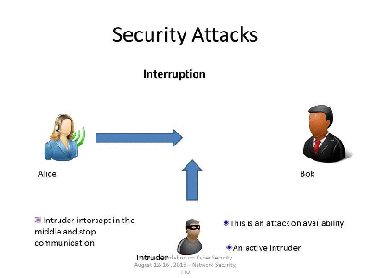

Figure 11: Interruption Attack. (["Security Attacks: Interruption"](https://discl.cs.ttu.edu/cybersecurity/lib/exe/fetch.php?w=400&tok=170a4e&media=output_deu9kd.gif) by Unknown, [CS Dept - Texas Tech University](http://cs.ttu.edu/) is licensed under [CC BY-SA 4.0](http://creativecommons.org/licenses/by-sa/4.0))

**Examples of Interruption attacks :**

* Overloading a server host so that it cannot respond.
* Cutting a communication line.
* Blocking access to a service by overloading an intermediate network or network device.
* Redirecting requests to invalid destinations.
* Theft or destruction of software or hardware involved.

**PRACTICAL 5**

**AIM: Understand the concept of firewall and configure the Statefull Packet Inspection(SPI) firewall IPTABLES.**

Stateful packet inspection is also known as dynamic packet filtering. What type of table does stateful packet inspection use for filtering? What are the attributes that are part of the state of the connection? How is stateful packet inspection different from static packet filters? How can stateful packet inspection improve network performance?

Stateful Packet Inspection (SPI) is a type of firewall technology that monitors and analyzes network traffic to ensure the security of the network. Unlike traditional packet filtering, SPI examines the data packets in context, tracking the state of connections and evaluating the contents of the packets themselves. This means that SPI firewalls can identify and block potentially harmful traffic, such as malicious packets and denial-of-service attacks. Additionally, SPI firewalls can dynamically adjust their filtering rules based on the state of the network traffic, allowing them to adapt to changing conditions and better protect the network. Overall, SPI is an effective and important tool for maintaining network security.

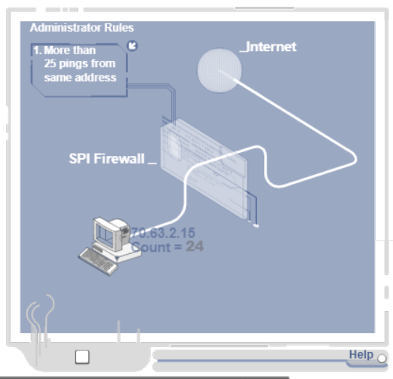

Stateful Packet Inspection (SPI) Firewalls, also known as dynamic packet filtering, improves static packet filtering by using a "state table" to keep track of legitimate Internet service requests.

SPI firewalls work by only allowing data through that comes from known and active connections. Any other data is rejected.

SPI firewalls record attributes including the requesting (egress) client's IP and port addresses, handshake (SYN-ACK-ACK) statuses, and egress routes. This group of attributes is collectively known as the state of the connection.

This firewall matches ingress traffic against these outgoing requests to ensure that each response is expected.

Stateful packet inspectors typically have the same features as static packet filters, but they're able to view more of the network packet to determine whether to allow or block traffic. Again, ingress packets that don't meet the criteria established by the SPI are discarded.

Stateful packet inspectors can increase the performance of some networks because they allow fewer packets to pass.

Stateful packet inspection uses a state table, also known as a connection table or session table, for filtering. This table contains information about active network connections, including the source and destination IP addresses, port numbers, and the state of the connection.

The attributes that are part of the state of the connection include the sequence numbers, acknowledgment numbers, and flags of the TCP protocol. Additionally, UDP protocols may use the source and destination port numbers and protocol type to track the state of the connection.

Stateful packet inspection differs from static packet filters in that it analyzes packets not only based on their individual characteristics, but also in the context of the current connection state. This allows it to filter traffic based on more sophisticated criteria, such as tracking the sequence of packets in a connection and identifying packet tampering or spoofing.

Stateful packet inspection can improve network performance by reducing the amount of unnecessary traffic that must be processed by the firewall. By tracking the state of connections, the firewall can allow legitimate traffic to pass through without requiring additional processing or rule checks. Additionally, stateful packet inspection can reduce the risk of false positives, allowing legitimate traffic to pass through more quickly and efficiently.

IPTABLES is a command-line tool used for configuring the Linux kernel firewall. IPTABLES can be used to set up a SPI firewall that can filter traffic based on various criteria, such as source and destination IP address, port number, and protocol type.

The following are the basic steps to configure an IPTABLES SPI firewall:

1. Check the current firewall rules: Use the following command to check the current firewall rules:

**iptables -L**

1. Set the default policy: Determine the default policy for each of the three built-in chains (INPUT, OUTPUT, and FORWARD). The default policy determines what happens to packets that don't match any of the rules. For example, to set the default policy to DROP for the INPUT chain, use the following command:

**iptables -P INPUT DROP**

1. Allow established connections: Allow traffic that is part of an established connection by using the following command:

**iptables -A INPUT -m conntrack --ctstate ESTABLISHED,RELATED -j ACCEPT**

1. Allow traffic for specific services: Allow traffic for specific services by opening ports in the firewall. For example, to allow traffic on port 80 for HTTP, use the following command:

**iptables -A INPUT -p tcp --dport 80 -j ACCEPT**

1. Block traffic: Block traffic by using the following command:

**iptables -A INPUT -j DROP**

1. Save the rules: Save the rules to the configuration file so that they persist after a reboot:

**iptables-save > /etc/sysconfig/iptables**

These are just basic steps for configuring an IPTABLES SPI firewall. It is important to have a good understanding of network security and to regularly update and test the firewall rules to ensure that the network is secure.

Other important considerations when configuring a firewall include:

* Defining rules based on the type of traffic that is allowed or blocked.
* Configuring rules based on the location of the traffic (internal or external to the network).
* Establishing a secure remote access policy for administrators.
* Creating rules for network segmentation to protect critical data and systems.
* Logging and monitoring firewall activity to detect and respond to potential security incidents.

**PRACTICAL 6**

**AIM: BASIC configuration of Intrusion Detection System: Snort.**

Like all Linux commands and applications, Snort also has the help of the command line, which can be invoked by using the following code:

|  |
| --- |
| kali > sudo snort –-help |

I have highlighted a few switches from the *Help* section of Snort:

* *-c* gives us the location of the Snort rules and tells it to use its rules. They are the signature against which the new packets are verified.
* *-d* tells Snort to show the application layer of data.
* –*e* displays the Data Link layer of information, which contains the MAC address of the system.
* –*i* allows the user to designate the interface we want to use. By default, Snort uses *eth0.*
* –*k* allows the users to define how they want to store the details of the data capture performed by Snort.
* *-v* is like in most of the programs — verbose, providing all the information.

[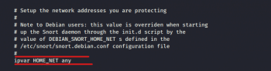](https://www.opensourceforu.com/wp-content/uploads/2020/04/conf_variable.png)

**Starting Snort**

Let’s get to know some of the basic switches of Snort, by first running *iy*. What makes Snort fabulous is that it can be run as a sniffer, packet logger, or even as a NIDS. In this article, we will look at Snort as a packet sniffer and NIDS.

To run Snort in packet dump mode, use the following command:

|  |
| --- |
| kali > sudo snort -vde |

The output we get is pretty self-explanatory (Figures 2). For using Snort as a NIDS, we need to instruct Snort to include the configuration file and rules. Generally, we can find the *conf* file at */etc/snort/snort.conf* and that file will point to Snort rules. We need to give the *-c* switch and then the location.

|  |
| --- |
| kali > sudo snort -vde -c /etc/snort/snort.conf |

We can also customise the rules to suit our needs.

[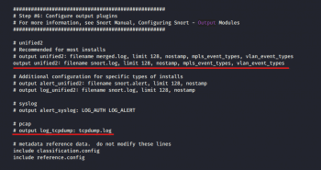](https://www.opensourceforu.com/wp-content/uploads/2020/04/conf_output.png)

**Snort — rules and configuration**

Like all general Linux applications, Snort is configured via a *conf* file, which can be opened as a simple text file. Edit this text file, restart the application and we have a new working configuration.

Before going any further, let’s take a brief look into the syntax of Snort rules.

* Snort rules must be contained in a single line or we can use the multi-line character \. For example:

|  |
| --- |
| log tcp !x.x.x/xx     OR    log tcp !x.x.x/xx any -> xxx \    (msg: “some command”) |

* All rules should contain a rule header (which identifies the actions) and rule options (which identify the rule’s alert messages).
* The rules must describe situations like a violation of the security policy of the company, or correctly detect the exploitable vulnerabilities.

There are three kinds of rules in Snort:

1. ***Alert rules*:** This generates alerts using the alert method.
2. ***Log rules***: Upon generation of any alert, it logs that specific alert.
3. ***Pass rules***: Ignores the packet if deemed malicious and drops it.

Now we can move on to the configuration file, which can be opened using the following command:

|  |
| --- |
| kali > mousepad /etc/snort/snort.conf |

In the Snort configuration file, we may see nine sections, as shown in Figure 4.

For the most basic configuration, we will address only Sections 1, 6 and 7 as seen in Figure 5, 6, 7.

[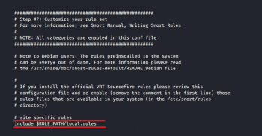](https://www.opensourceforu.com/wp-content/uploads/2020/04/conf_rules.png)

**Setting variables** : In the screenshot in Figure 5, we can see the highlighted line ‘ipvar HOME_NET’. This variable denotes the network is protected. ‘HOME_NET’ is the variable name to which the IP address is assigned. This can be a single IP address, a list of IP addresses, or a subnet in CIDR notation, or even can be left as any.

**Checking the output** : Using *Ctrl+F*, we then move on to output plugins (Figure 6). By default, Snort sends the output in log format. But if we want, we can comment out that line (*unified2*) and uncomment the bottom line (*log_tcpdump*), enabling the output in tcpdump format, which is saved in the */var/log/snort* directory.

**Disable rules** : Depending on your enterprise, we may need to change the rules that Snort relies upon, and customise them in Section 7, as shown in Figure 7.

To not let Snort use a given set, simply comment out the *include*part.

After making any change, simply save the file and test the configuration using the *-T* switch.

|  |
| --- |
| kali > sudo snort -T -c  /etc/snort/snort.conf |

[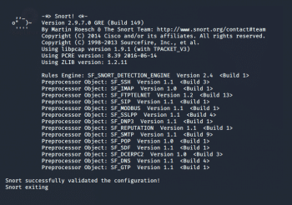](https://www.opensourceforu.com/wp-content/uploads/2020/04/conf_validate.png)

**PRACTICAL 7**

**AIM: Network vulnerability assessment using OpenVAS/Necuss Framework.**

OpenVas is an open source vulnerability scanning tool. In this example we will use OpenVas to scan a target machine for vulnerabilities. We will also use two virtual machines in an isolated virtual environment. Our host machine will be a kali linux vm and we are going to scan a virtual machine with metasploitable framework which is by default full of vulnerabilities.

**STEP 1 / Starting OpenVas Services**

To Start OpenVas Services we can find it in Applications in the section of Vulnerability Analysis

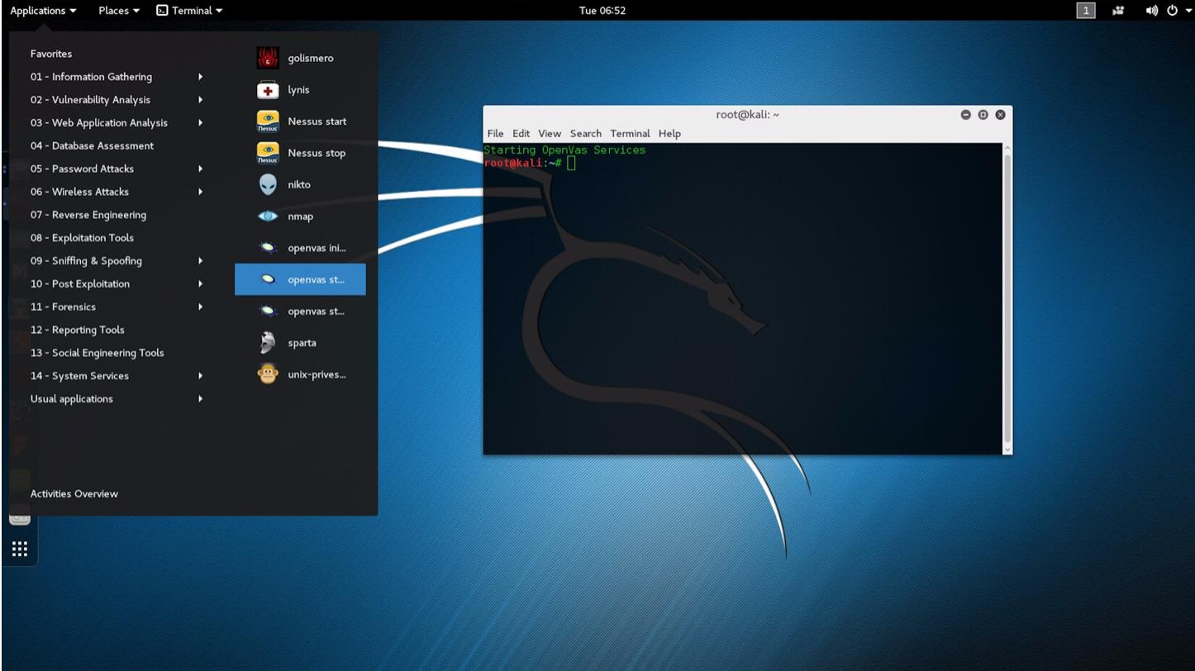

**STEP 2 / Loading OpenVas Interface**

To load OpenVas Interface you should open iceweasel and type [https://127.0.0.1:9392](https://127.0.0.1:9392/). By default OpenVas run on port 9392. For credentials you can use U:admin P:letmein

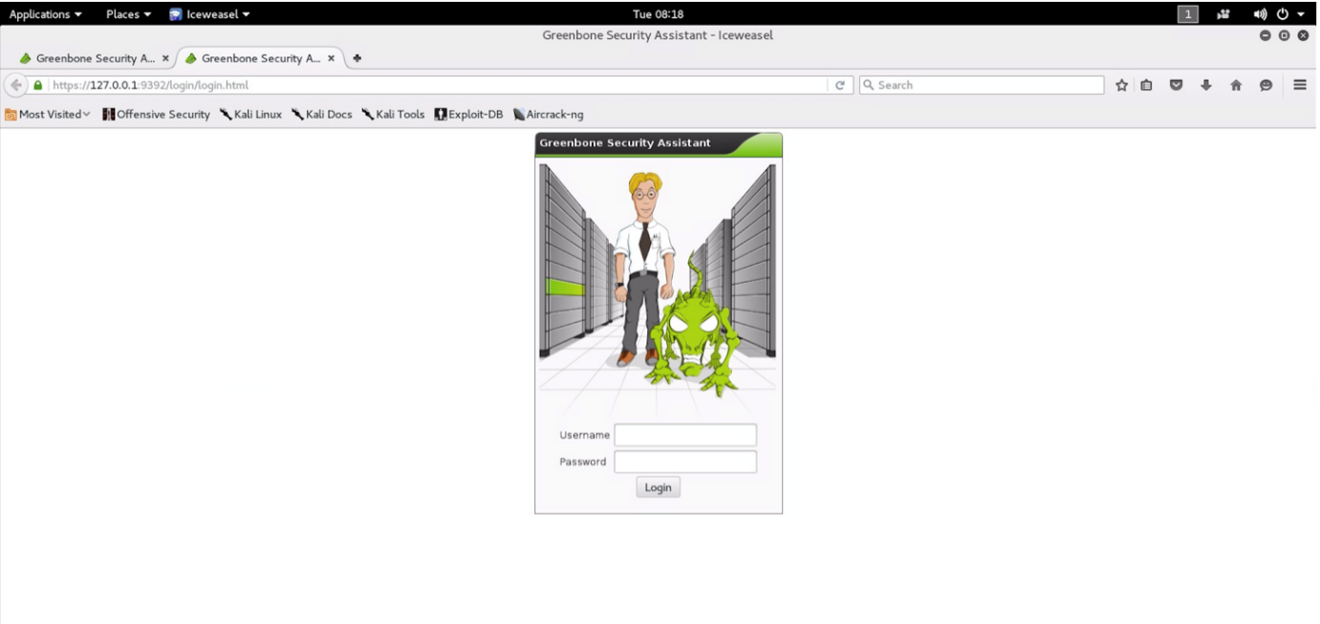

**STEP 3 / Creating New Target**

To perform a new scan we have to create our target first. To do that you can go to Targets through the Configuration button in the menu bar To create your target click on the star button.

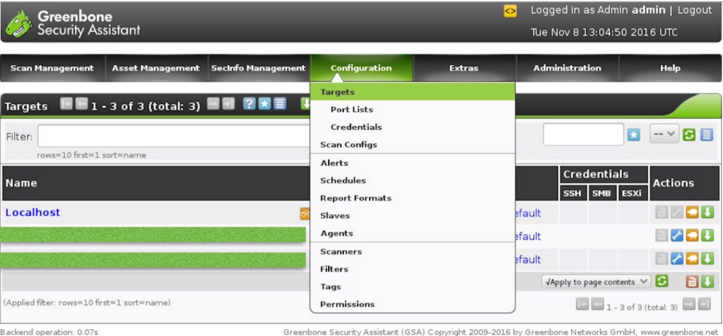

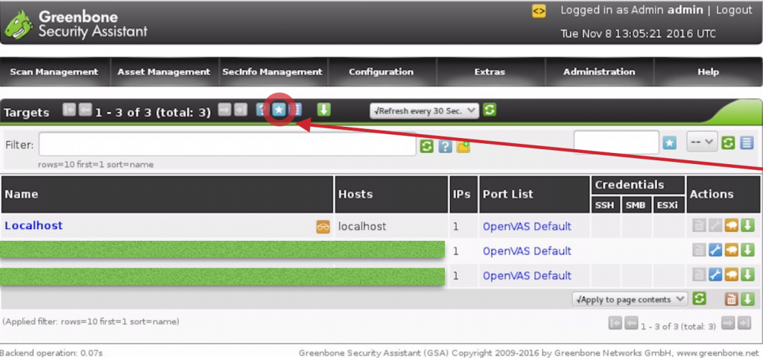

A new window will open. Fill the fields according to needs of the assessment. In this example we will use the IP of the target machine manually.

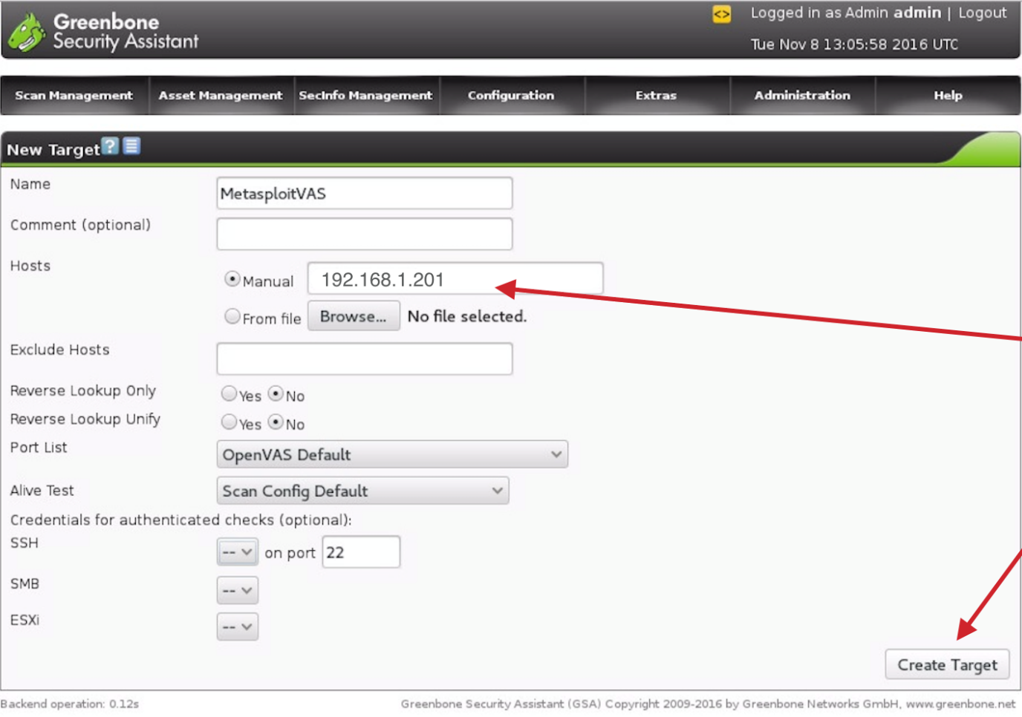

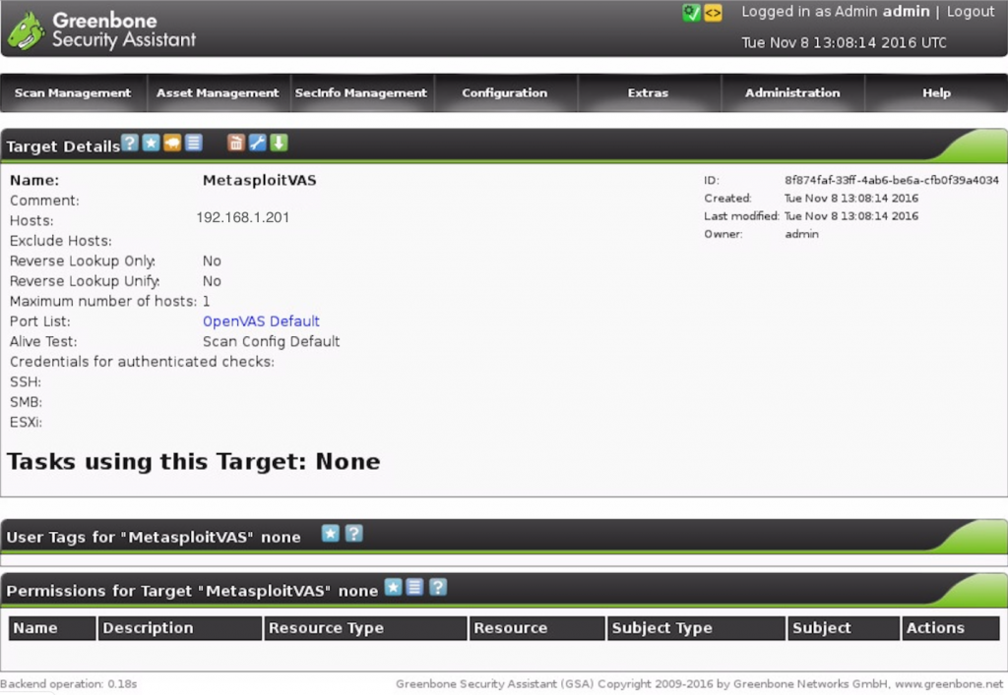

**STEP 4 / Creating New Task**

Immediately after the creation of our target we will proceed to the task section in order to create a new task for our new target. To create a new task we have to move on the task section from the menu bar as the images illustrate. To create new task we should click on the star button.

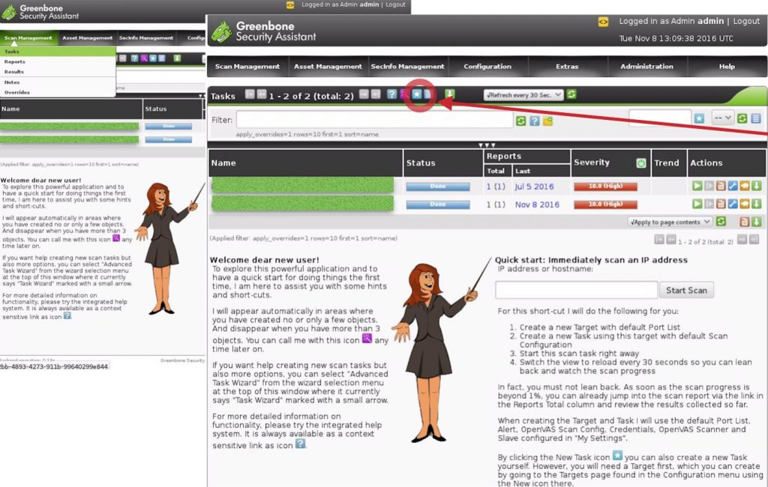

The next move is to fill the fields with the necessary details. On the “Scan Targets” we choose the target that we have created before. Furthermore, for the purposes of this example we will choose the default OpenVas Scanner.

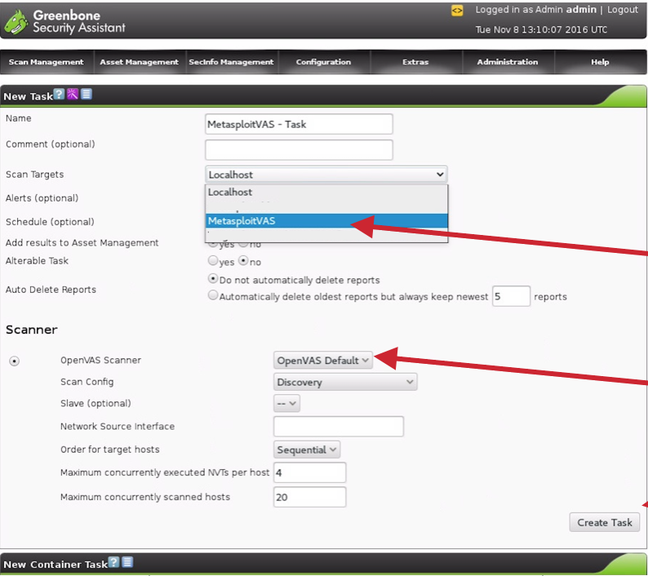

**STEP 5 / Start Scanning**

We almost finished. Now we can start scanning our target (click on the play button) and wait until it finish.

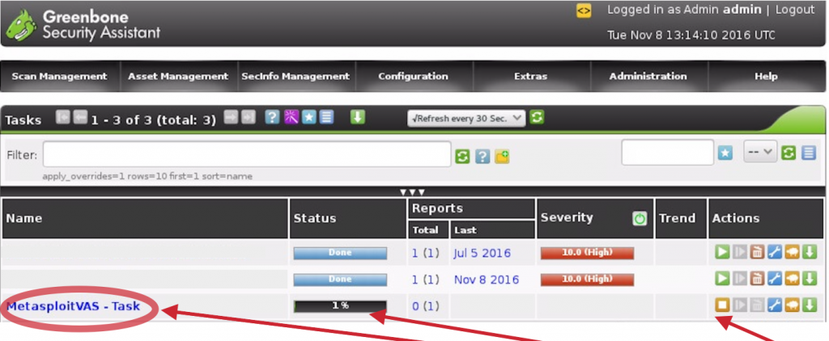

**STEP 6 / Study the Results and Export your Report**

When the scan will be completed you are able to see the details of each vulnerability that has been found during the scanning procedure. As you can see in the image below in our report there are a lot of critical vulnerabilities. This is because we scanned a vm with metasploitable framework which is by default a vulnerable machine. At this point your employer needs to read your own report not the exported report of OpenVas. So, the best practise is to write your own report listing your findings including suggestions and advices.

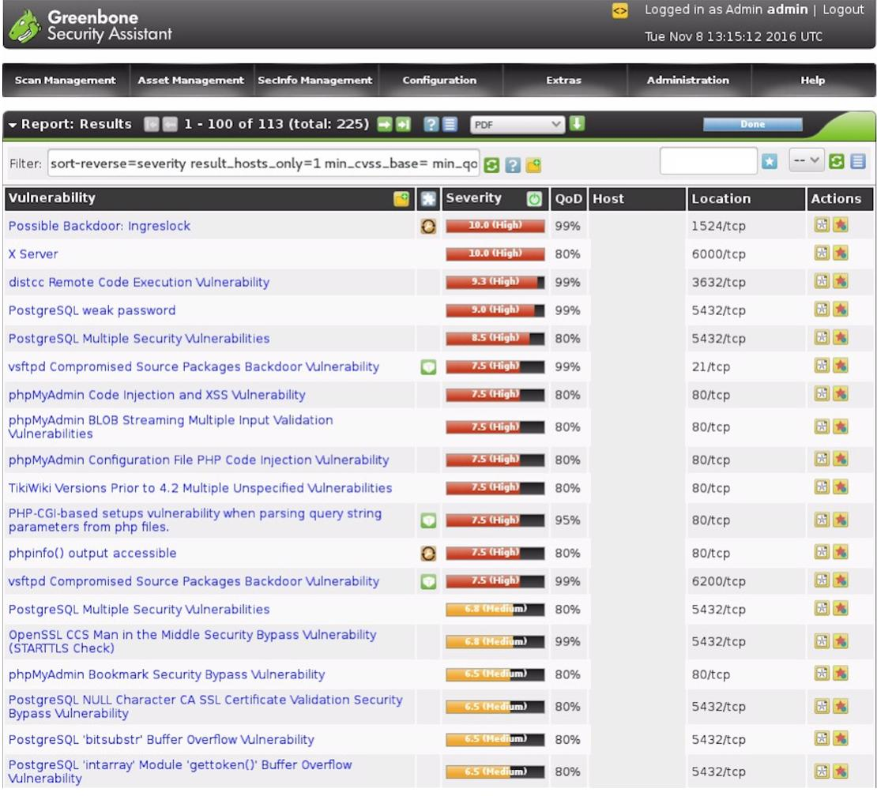

**PRACTICAL 8**

**AIM: Demonstrate automated SQL injection with SqLMap.**

SQL Injection is a code injection technique where an attacker executes malicious SQL queries that control a web application’s database. With the right set of queries, a user can gain access to information stored in databases. SQLMAP tests whether a ‘GET’ parameter is vulnerable to SQL Injection.

$variable = $_POST['input'];

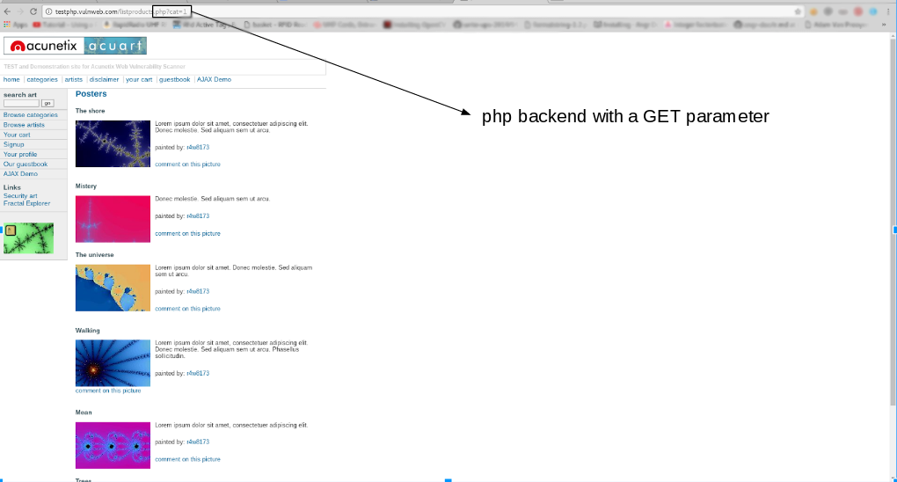mysql_query("INSERT INTO `table` (`column`) VALUES ('$variable')");

A simple test to check whether your website is vulnerable would be to replace the value in the get request parameter with an asterisk (*). For example, 

http://testphp.vulnweb.com/listproducts.php?cat=*

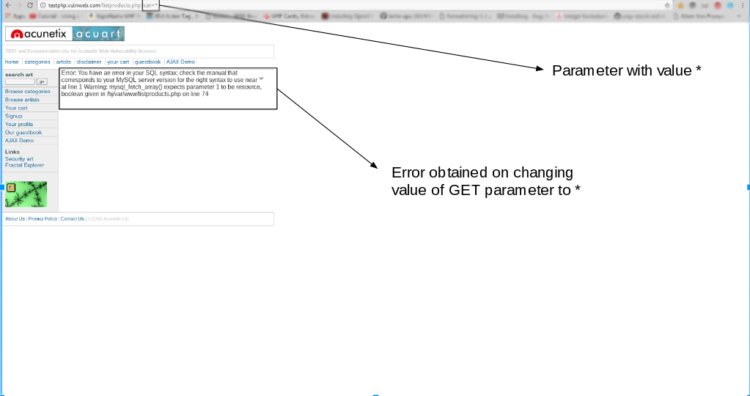

If this results in an error such as the error given above, then we can conclusively say that the website is vulnerable.

**Installing sqlmap**

SQLMAP comes pre – installed with kali linux, which is the preferred choice of most penetration testers. However, you can install sqlmap on other debian based linux systems using the command

sudo apt-get install sqlmap

**Usage**

In this article, we will make use of a website that is designed with vulnerabilities for demonstration purposes: 

http://testphp.vulnweb.com/listproducts.php?cat=1

As you can see, there is a GET request parameter (cat = 1) that can be changed by the user by modifying the value of cat. So this website might be vulnerable to SQL injection of this kind.   
To test for this, we use SQLMAP. To look at the set of parameters that can be passed, type in the terminal, 

sqlmap -h

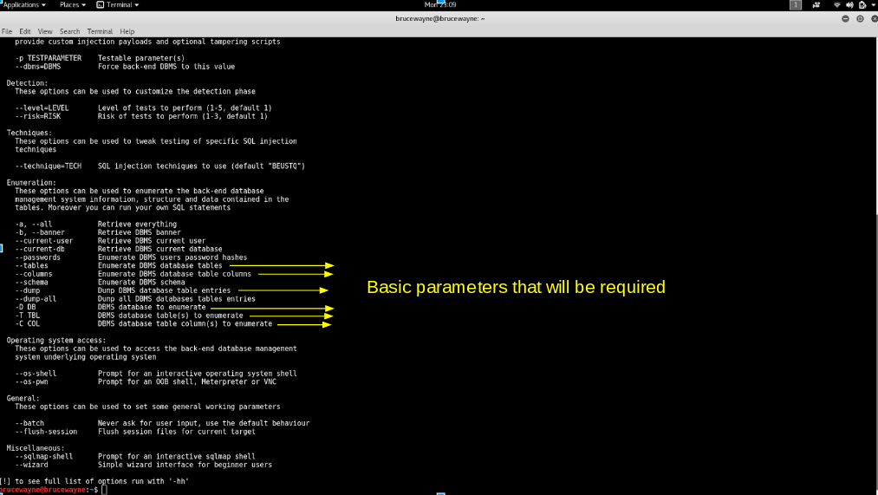

The parameters that we will use for the basic SQL Injection are shown in the above picture. Along with these, we will also use the –dbs and -u parameter, the usage of which has been explained in Step 1.   
**Using SQLMAP to test a website for SQL Injection vulnerability:** 

1. **Step 1: List information about the existing databases**  
   So firstly, we have to enter the web url that we want to check along with the -u parameter. We may also use the –tor parameter if we wish to test the website using proxies. Now typically, we would want to test whether it is possible to gain access to a database. So we use the –dbs option to do so. –dbs lists all the available databases.

sqlmap -u http://testphp.vulnweb.com/listproducts.php?cat=1 --dbs



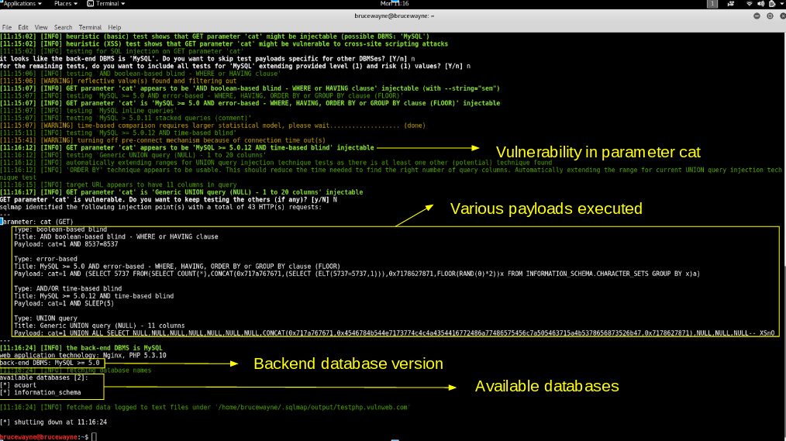

1. We get the following output showing us that there are two available databases. Sometimes, the application will tell you that it has identified the database and ask whether you want to test other database types. You can go ahead and type ‘Y’. Further, it may ask whether you want to test other parameters for vulnerabilities, type ‘Y’ over here as we want to thoroughly test the web application.

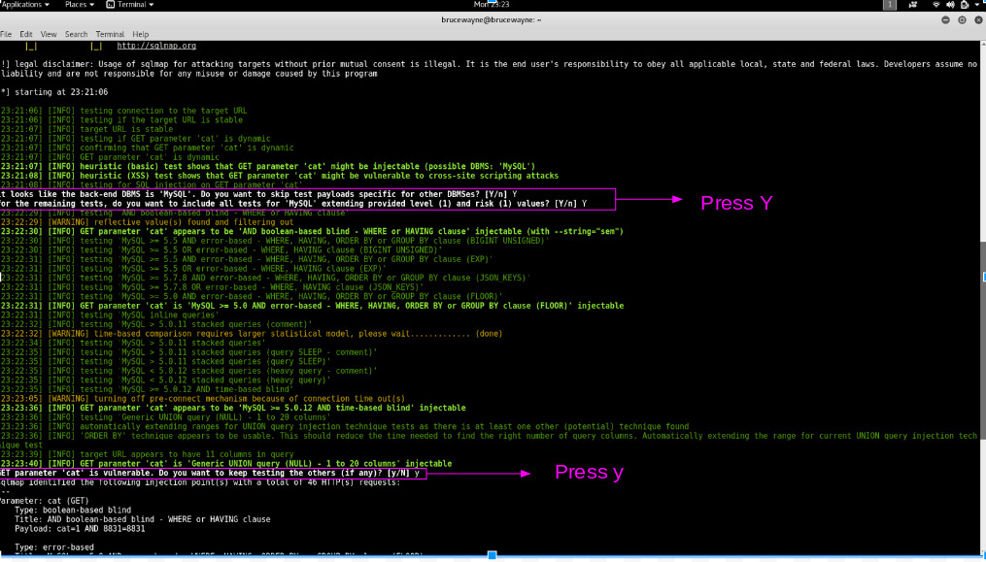

1. We observe that there are two databases, acuart and information_schema

1. **Step 2: List information about Tables present in a particular Database**  
   To try and access any of the databases, we have to slightly modify our command. We now use -D to specify the name of the database that we wish to access, and once we have access to the database, we would want to see whether we can access the tables. For this, we use the –tables query. Let us access the acuart database.

sqlmap -u http://testphp.vulnweb.com/listproducts.php?cat=1

-D acuart --tables



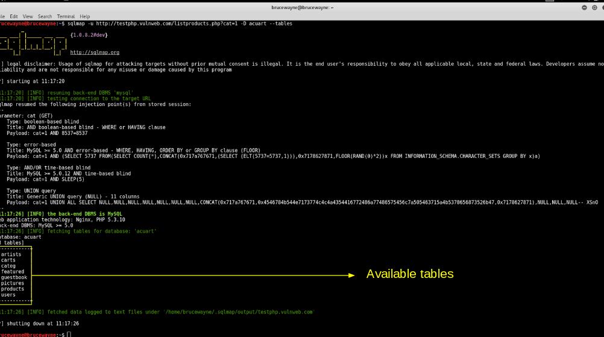

*Tables*

1. In the above picture, we see that 8 tables have been retrieved. So now we definitely know that the website is vulnerable.
2. **Step 3: List information about the columns of a particular table**

If we want to view the columns of a particular table, we can use the following command, in which we use -T to specify the table name, and –columns to query the column names. We will try to access the table ‘artists’. 

sqlmap -u http://testphp.vulnweb.com/listproducts.php?cat=1

-D acuart -T artists --columns



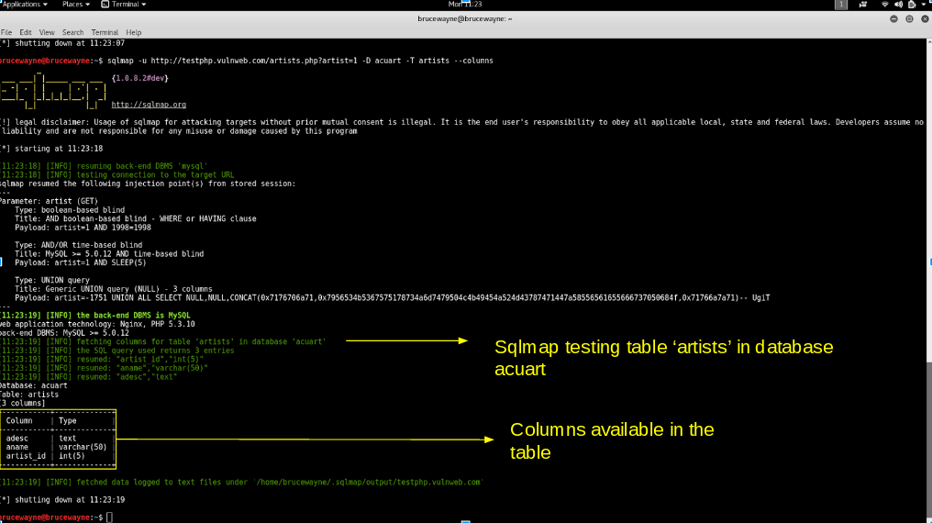

*Columns*

2. **Step 4: Dump the data from the columns**  
   Similarly, we can access the information in a specific column by using the following command, where -C can be used to specify multiple column name separated by a comma, and the –dump query retrieves the data

sqlmap -u http://testphp.vulnweb.com/listproducts.php?cat=1

-D acuart -T artists -C aname --dump



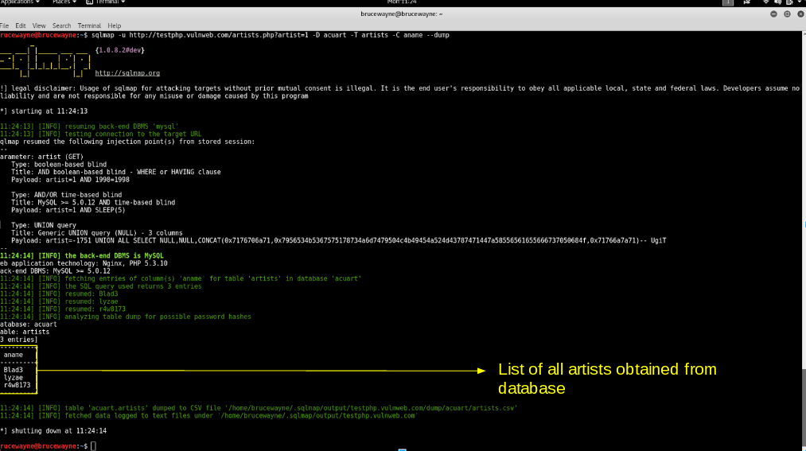

1. From the above picture, we can see that we have accessed the data from the database. Similarly, in such vulnerable websites, we can literally explore through the databases to extract information

**Prevent SQL Injection**

SQL injection can be generally prevented by using **Prepared Statements**. When we use a prepared statement, we are basically using a template for the code and analyzing the code and user input separately. It does not mix the user entered query and the code. In the example given at the beginning of this article, the input entered by the user is directly inserted into the code and they are compiled together, and hence we are able to execute malicious code. For prepared statements, we basically send the sql query with a placeholder for the user input and then send the actual user input as a separate command.   
Consider the following php code segment. 

$db = new PDO('connection details');

$stmt = db->prepare("Select name from users where id = :id");

$stmt->execute(array(':id', $data));

In this code, the user input is not combined with the prepared statement. They are compiled separately. So even if malicious code is entered as user input, the program will simply treat the malicious part of the code as a string and not a command.

**PRACTICAL 9**

**AIM: Demonstrate Application Injection using Zed Attack Proxy.**

The Zed Attack Proxy (ZAP) is an easy to use integrated [penetration testing](https://www.sciencedirect.com/topics/computer-science/penetration-testing) tool for finding vulnerabilities in web applications.

It is designed to be used by people with a wide range of security experience and as such is ideal for developers and functional testers who are new to penetration testing.

ZAP provides automated scanners as well as a set of tools that allow you to find [security vulnerabilities](https://www.sciencedirect.com/topics/computer-science/security-vulnerability) manually.

https://www.owasp.org/index.php/OWASP_Zed_Attack_Proxy_Project

ZAP is a yet another fantastic open-source tool that we can take advantage of, however the full suite of features it provides is way beyond the scope of this book. What we are interested in for now is its spidering ability.

The ZAP is so called because it proxies your connections out to your target of choice. This gives ZAP the ability to intercept and tamper with any outbound request or inbound response.

After launching ZAP, you configure your browser to point at it by configuring localhost and port 8080 in your proxy settings. I use the FoxyProxy add-on for Firefox, but there are alternatives out there for other browsers. You could just use the standard proxy settings if you choose. FoxyProxy and applications like it are far quicker if you are going to be changing things around a lot, and you probably will.

Setting up ZAP

To begin with, you need to [download](https://www.owasp.org/index.php/OWASP_Zed_Attack_Proxy_Project) and install OWASP ZAP scanner and set it up correctly. ZAP is platform agnostic so you can install it on Windows, Linux or Mac OS. You need Java 8+ installed on your [Windows](https://java.com/en/download/win10.jsp) or [Linux](https://www.java.com/en/download/help/linux_x64_install.xml) system.

For the purposes of this article, I’m going to concentrate on its use on Windows.

Starting ZAP

Once setup you can start ZAP by clicking the ZAP icon on your Windows desktop or from the start menu.

When the app launches, it asks you whether you want to save the session or not. If you want to use the current run configuration or test results later, you should save the session for later. For now let’s select *“No, I do not want to persist this session at this moment in time”*.

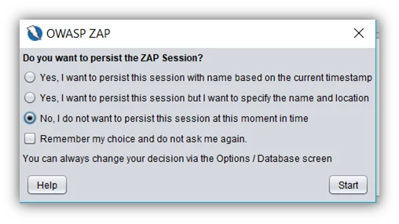

Figure 1. OWASP ZAP start-up dialog

Once you click the *“Start”*button, the ZAP UI will be launched.

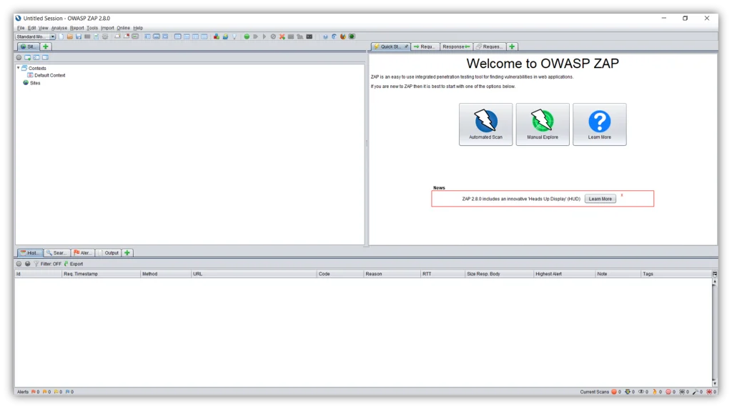

Figure 2. ZAP UI

Spidering the web application

Spidering a web application means crawling all the links and getting the structure of the application. ZAP provides two spiders for crawling web applications;

1. Traditional ZAP spider:

The traditional ZAP spider discovers links by examining the HTML in responses from the web application. This spider is fast, but it is not always effective when exploring an AJAX web application.

1. AJAX spider:

This is more likely to be effective for AJAX applications. This spider explores the web application by invoking browsers which then follow the links that have been generated. The AJAX spider is slower than the traditional spider.

Automated scan

This option allows you to launch an automated scan against an application just by entering the URL. If you are new to ZAP, it is best to start with Automated Scan mode.

To run a Quick Start Automated Scan:

1. Start Zap and click the large ‘Automated Scan’ button in the ‘Quick Start’ tab.
2. Enter the full URL of the web application you want to attack in the ‘URL to attack’ text box.
3. Click the ‘Attack’ button.

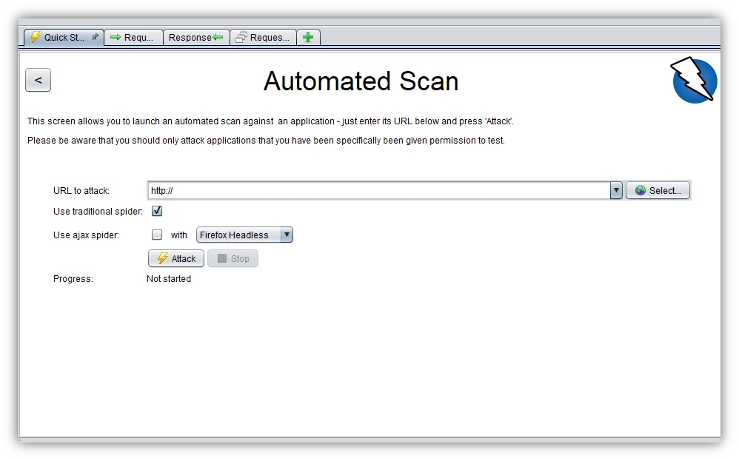

Figure 3. ZAP Automated Scan window

Once you click the ‘Attack’ button, ZAP will start crawling the web application with its spider and passively scan each page it finds. Then ZAP will use the active scanner to attack all of the discovered pages, functionality and parameters.

Exploring the web application manually

Spiders are a great way to explore the basic site, but they should be combined with manual exploration to be more effective. This functionality is very useful when your web application needs a login or contains things like registration forms, etc.

You can launch browsers that are pre-configured to proxy through ZAP via the Quick Start tab. Browsers launched in this way will also ignore any certificate validation warnings that would otherwise be reported.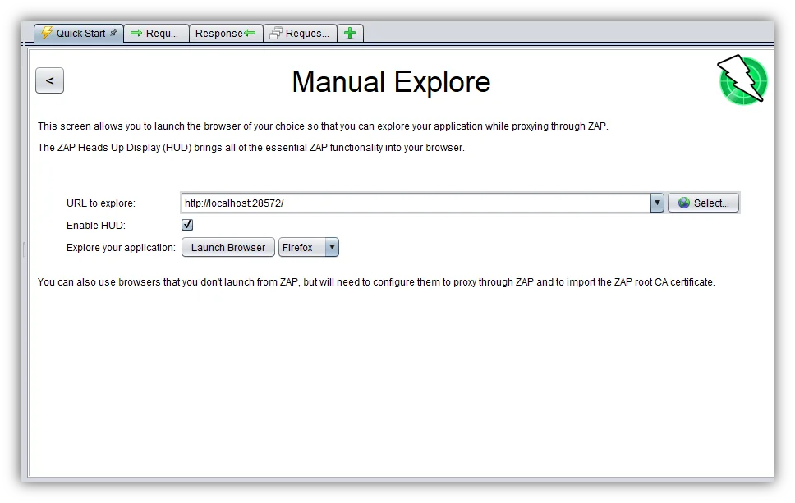

Figure 4. ZAP Manual Explore window

To Manually Explore the web application:

* Start ZAP and click on the large ‘Manual Explore’ button in the Quick Start tab.
* Enter the full URL of the web application to be explored in the ‘URL to explore’ text box.
* Select the browser you would like to use and click the ‘Launch Browser’ button.

This will launch the selected browser with a new profile. Now explore all of the targeted web applications through this browser. ZAP passively scans all the requests and responses made during your exploration for vulnerabilities, continues to build the site tree, and records alerts for potential vulnerabilities found during the exploration.

What is passive scanning?

Passive scans only scan the web application responses without altering them. It does not attack or insert malicious scripts to the web application, so this is a safe scan; you can use it if you are new to security testing. Passive scanning is good at finding some vulnerabilities and as a way to get a feel for the basic security of a web application.

What is active scanning?

Active scan attacks the web application using known techniques to find vulnerabilities. This is a real attack that attempts to modify data and insert malicious scripts in the web application.

Active scans put the application at risk, so do not use active scanning against web applications you do not have permission to test.

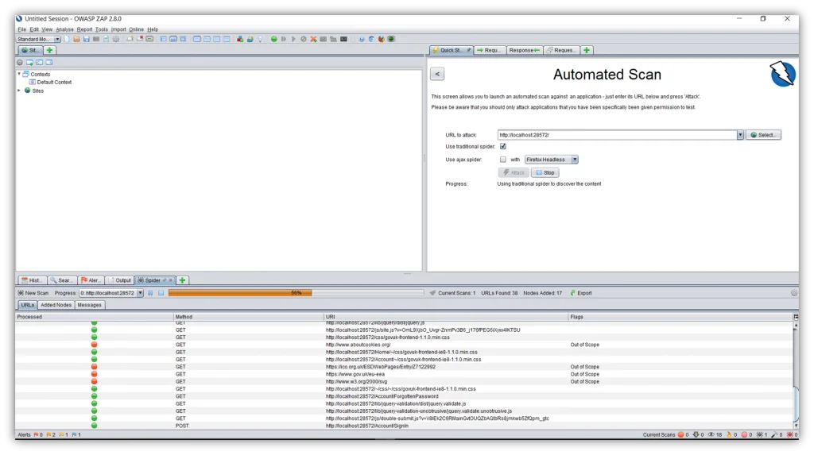

Figure 5. Running Automated scan against the web application

Inspecting the test results

Once the scan is completed, ZAP generates a list of issues that are found during the scan. These issues can be seen on the *Alerts* tab that is located in the bottom pane. All the issues are marked with colour coded flags. You can also generate an HTML scan report through the ‘Report’ menu option on the top of the screen.

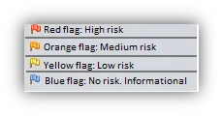

Figure 6. ZAP scan report risk categories

**PRACTICAL 10**

**AIM: Perform web application testing using DVWA.**

**1. Perform Manual SQL injection**

**2. XSS using DVWA**

SQL injection is considered a high risk vulnerability due to the fact that can lead to full compromise of the remote system.This is why in almost all web application penetration testing engagements,the applications are always checked for SQL injection flaws.A general and simple definition of when an application is vulnerable to SQL injection is when the application allows you to interact with the database and to execute queries on the database then it is vulnerable to SQL injection attacks.

There are many vulnerable applications that you can try in order to learn about SQL injection exploitation but in this article we will focus on the Damn Vulnerable Web Application (DVWA) and how we can extract information from the database by using SQL injection.Of course the methodology can be used and for any real life scenario in web application penetration tests.

In order to exploit SQL injection vulnerabilities we need to figure out how the query is built in order to inject our parameter in a situation that the query will remain true.For example in the DVWA we can see a text field where it asks for user ID.If we enter the number 1 and we click on the submit button we will notice that it will return the first name and the surname of the user with ID=1.

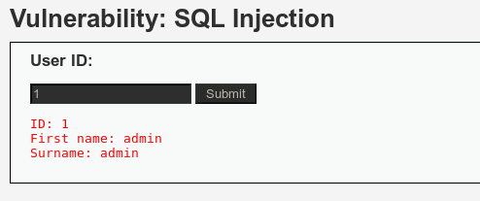

The next step will be to try to identify what kind of database is running on the back-end in order to construct the queries accordingly and to extract the information that we want.This is very important because If we don’t know the database that exists behind we will not be able to exploit successfully the SQL injection vulnerability.Most of the times the web application technology (Java,ASP.NET,PHP etc.) will give us an idea of the database that the application is using.For example ASP.NET applications often using Microsoft SQL Server,PHP applications is likely to use MySQL and Java probably Oracle or MySQL.Additionally we can assume the database type from the web server and operating system of the target.For example if the web server is running Apache and PHP and it is a Linux host then the database has more possibilities to be MySQL.If it is an IIS then it is probably Microsoft SQL Server.Of course we cannot rely on these information,this is just for giving us an indication in order to speed the database fingerprint process.

We can very easily identify the database type especially if we are in a non-blind situation.The basic idea is to make the database to respond in a way that it will produce an error message that it will contain the database type and version. For example this can be achieved by a single quote because it will force the database to consider any characters that are following the quote as a string and not as SQL code and it will cause a syntax error.So now if we add a single quote on the vulnerable parameter id=’ this will make the database to generate an error message which as we can see from the image below it contains the database type which is MySQL server.

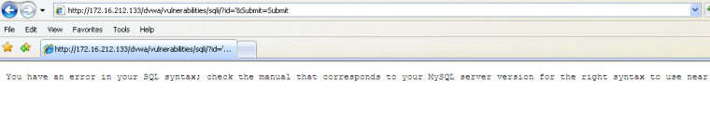

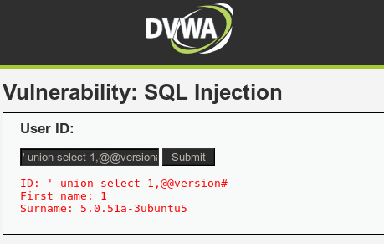

**PRACTICAL 11**

**AIM: Perform brute force attack using John the RIPPER**

1. Cracking a zip/rar password-protected fileCracking a zip or rar file password is done using the same approach.

First, we will need to access the hash of the password we are going to crack. Note the name of your zip file as you will be required to state it in the rest of the commands.

To access the password hash, navigate to the location of your zip password-protected file and run the command below in the terminal:

You can export the output to a text document to save the password hash since we are going to use it later.

zip2john Test.zip > hash.txt

john --format=zip hash.txt

In the command above, we have specified the format of the target file.

The password cracking process is initiated. This is where the strength of the password comes in. The stronger the password, the more the time taken to perform an attack.

After a successful attack, the password will be displayed on the terminal.

Cracking a zip or rar file password is done using the same approach.

First, we will need to access the hash of the password we are going to crack. Note the name of your zip file as you will be required to state it in the rest of the commands.

To access the password hash, navigate to the location of your zip password-protected file and run the command below in the terminal:

zip2john Test.zip

You can export the output to a text document to save the password hash since we are going to use it later.

zip2john Test.zip > hash.txt

To begin the attack on your zip file, run the command below:

john --format=zip hash.txt

In the command above, we have specified the format of the target file.

The password cracking process is initiated. This is where the strength of the password comes in. The stronger the password, the more the time taken to perform an attack.

After a successful attack, the password will be displayed on the terminal.